273/1
GEOGRAPHY
Paper 1
2 HOURS

ENTEBBE BRIGHT SECONDARY SCHOOL NKUMBA KISEMBI
BEGNNING OF TERM 3 EXAMINATIONS 2022
Uganda Certificate of Education
S.3 GEOGRAPHY
Paper 1
2 Hours

INSTRUCTIONS TO CANDIDATES
- This paper consists of Part I and II.
- Part I and section A are compulsory.
- Answer only one question from section B of Part II.
- Any additional question(s) attempted will not be marked.

PART 1
OBJECTIVE TYPE QUESTIONS (30 Marks)

- The total number of people divided by a country’s total land area gives the population
- Distribution B. size C. structure D. density
- The relief division in East Africa which lies between 1500 – 6000 metres above the sea level is called ……………….
- The coastal plains B. Nyike plateau
- The highlands of East Africa D. Rift valley
- Former Namanve forest has been cleared mainly for …………………
- Industrialisation B. farming
C. road transport D. settlement
- L. Katwe in south western Uganda is an example of
- Chemically sedimentally rock B. mechanically sedimentary rock
C. metamorphic rock D. igneous rock
- Station X in East Africa receive annual rainfall of 1506mm per year. Therefore, the mean annual rainfall for station X is
- 125mm B. 1506mm C. 3000mm D. 18000mm
- Station X receives annual rainfall which can be described as
- Moderate B. heavy C. unreliable D. high
- Which of the following crops in East Africa grow well in areas of low rainfall?
- Cotton
- Sisal
- Tea
- Pyrethrum
- 3 and 4 B. 2 and 3 C. 1 and 3 D. 1 and 2
- Which of the following heavy industries are found in East Africa?
- Ship building and textiles
- Food processing and car assembly
- Textiles and food processing
- Ship building and car assembly.
- The Uganda’s leading invisible export is
- Cocaine B. skilled labour
C. tourism D. hydro electricity
- The major problem resulting from rapid urbanization in Kenya is
- Unemployment B. shortage
C. Poor sanitation D. Shortage of agricultural land
- Normal faults are associated with
- tensional forces B. compressional forces
C. glaciation D. vulcanicity
- The greatest problem facing fresh water fishing grounds in East Africa is
- Indiscriminate fishing B. water pollution
C. poor transport D. changing water levels
- Which of the following rivers in East Africa has oxbow lakes?
- Kafu B. tana C. Kagera D. Nzoia
- Sisal growing in Tanzania has declined mainly due to
- Limited capital to invest
- Soil exhaustion
- Limited market
- Competition for land with food crops.
- Gold in East Africa is not exploited on a large scale because
- The method of mining is expensive B. The deposits are in small quantities
C. World markets prices keep changing D. Of competition from other produces
- Which of the following modes of transport in Uganda has declined in importance?
- Air B. water C. road D. railway
- The wind word side of Mt. Rwenzori is wet mainly because of
- Thick forest cover B. high altitude
C. presence of rivers D. ascending winds
- A deep Hollow found at the head of a glaciated valley is called
- A rete B. Cirque C. Hanging valley D. truncated spur
- The mangrove type of vegetation in east Africa is found
- A long the coast B. around Lake Victoria
C. on the Nyika plateau D. in the Highlands
- Which of the following is a characteristic of clay soil?
- Retains much water B. is well aerated
C. is rich in humus D. has large particles
- The method used for mining diamonds at Mwadui is
- Adit B. Open cast C.deep pit D. Alluvial

- Coral reefs are not found at the mouths of rivers on the East African coast because the water is
- Warm B. salty C. muddy D. shallow
- Weathering by frost action in East Africa has been experienced in the
- Rift valley areas B. coastal regions
C. Mountainous areas D. central plateau
- Marine fishing at the East African coast has been affected by
- Lack of mechanized fishing vessels
- Availability of unskilled labour
- Limited fish species
- Presence of coral reefs.
- The problem of traffic congestion in Kampala is being solved by
- Increasing number of traffic police
- Installing traffic lights
- Encouraging use of public transport
- Constructing fly overs.
- Which one of the following is a characteristic of trees in savannah regions of East Africa?
- Periodic shedding of leaves B. presence of buttress roots
C. forming of a dense canopy D. stems of over sixty metres.
- Mount Suswa in Kenya was formed by
- Folding B. vulcanicity C. upwarping D. step faulting
- Congestion at the port of Dar-es-salaam can best be reduced by
- Dredging B. containerization
C. traffic control D. vessel diversion
- Hale power project is found on river
- Pangani B. Tana C. Rufugi D. Ruaha
- The speed of wind at a weather station is measured by
- Wind vane B. sixth’s thermometer
C. anemometer D. Barometer

PART II
PHOTOGRAPH INTERPRETATION, FIELD WORK AND EAST AFRICA
Answer 3 questions from part II including questions 1, 2 and 3 which are compulsory.

SECTION A
- PHOTOGRAPH INTERPRETATION (COMPULSORY) (15MARKS)
Study the photograph provided below and answer the questions that follow
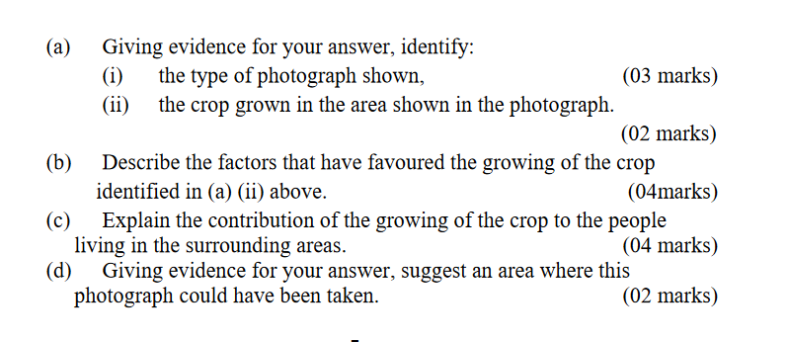
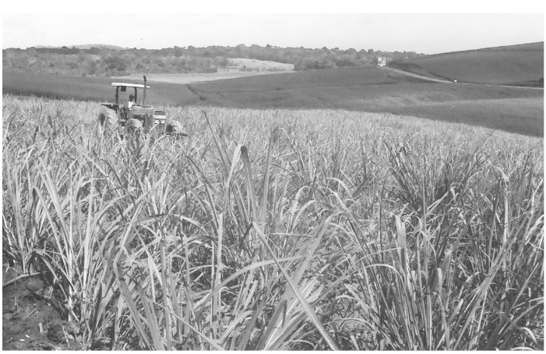

- COMPULSORY FIELD WORK QUESTION (15MARKS)

For any one field work study you have conducted
- State the
- Topic (02marks)
- Objectives of the field work study. (02marks)
- Explain the preparation steps you took before rear fieldwork. (03marks)
- Draw a cross-section of the area studied and on it mark and name
- Physical features
- Land use activities (04marks)
- Outline the follow up activities carried out after the field work study. (04marks)
SECTION B (20MARKS)
EAST AFRICA
Answer only one question from this section

- Study the table below showing the climate of station X in East Africa and answer the questions that follow.
Station X (altitude 1067 metres)
Month | J | F | M | A | M | J | J | A | S | O | N | D
Temperature °C | 23 | 23 | 22 | 22 | 22 | 20 | 19 | 19 | 22 | 24 | 25 | 24
Rainfall (mm) | 203 | 191 | 356 | 244 | 627 | 109 | 33 | 31 | 28 | 5 | 114 | 190
Source: Hickman G 1995 Lands and peoples of East Africa. P33
- Draw a suitable graph to show the climate of the station. (07marks)
- Calculate the;
- Annual rainfall total (01mark)
- Mean annual rainfall (01mark)
- Range of temperature for station X (01mark)
- (i) Describe the characteristics of the climate experiences at station X (04marks)
(ii) Explain the challenges face people who live near station X. (04marks)
- Giving reasons for your answer, state the hemisphere in which station X is found
(02marks) END

